Student Name and Roll Number : Khyati Dhawan 21CSU047
Semester /Section: 5th semester FS-A
Date: 19/8/23

Assignment 1: No SQL Databases (10 questions done)
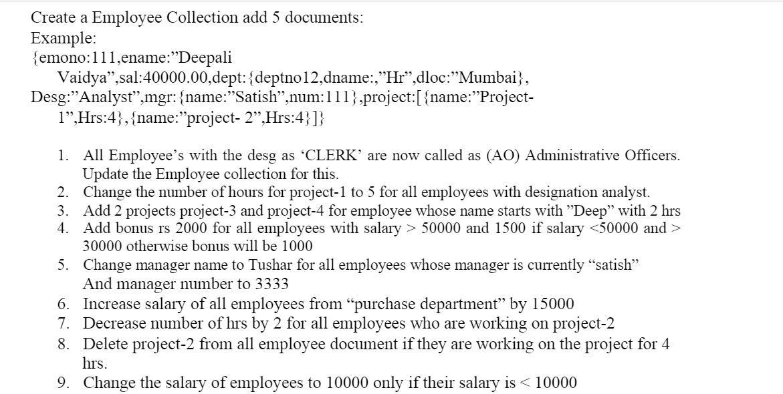
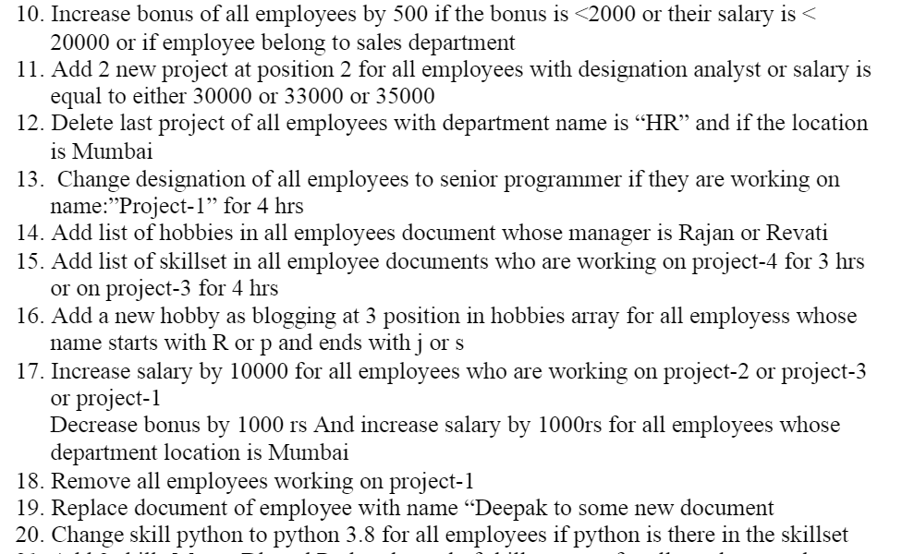
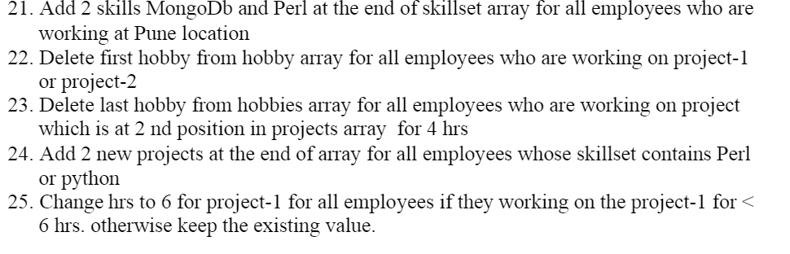

Question 1. ----------------------------------------------------------------------------------------------------------------------
db.employees.updateMany(
{ "Desg": "Clerk"},
{ $set : { "Desg": "AO"} }
)
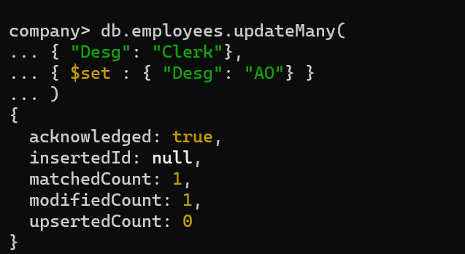

Question 2. ---------------------------------------------------------------------------------------------------------------------- $set:
The $set operator replaces the value of a field with the specified value.
The $set operator expression has the following form: { $set: { <field1>: <value1>, ... } }
To specify a <field> in an array, we use dot notation.
The positional $ operator acts as a placeholder for the first match of the update query document.

db.employees.updateMany(
{ "Desg": "Analyst" , "project.name": "Project-1"},
{ $set : { "project.$.Hrs" : 5 } }
)
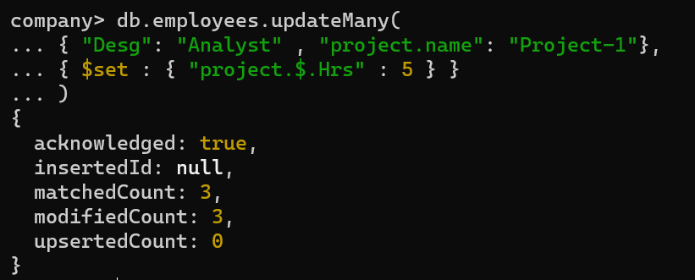

Question 3. ----------------------------------------------------------------------------------------------------------------------$push:
It adds an array to our document if it doesn’t already exists. If it Does exists then it adds
The elements associated with it at to the last of it.
$each:
MongoDB provides different types of array update operators to update the values of the array fields in the documents and $each modifier is one of them.
This modifier is used to append multiple values to the array field.
If we use $each modifier with $push operator, then it appends multiple values to an array field.

Db.employees.updateMany(
{“ename”: /^Deep/},
{$push: {“project”: { $each :
[
{ “name”:”Project-4”,”Hrs”:2},
{“name”:”Project-5”,”Hrs”:2}
]
} } } )

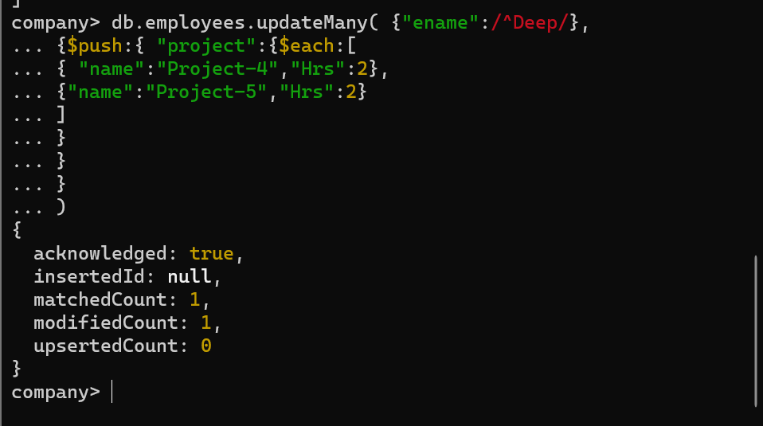
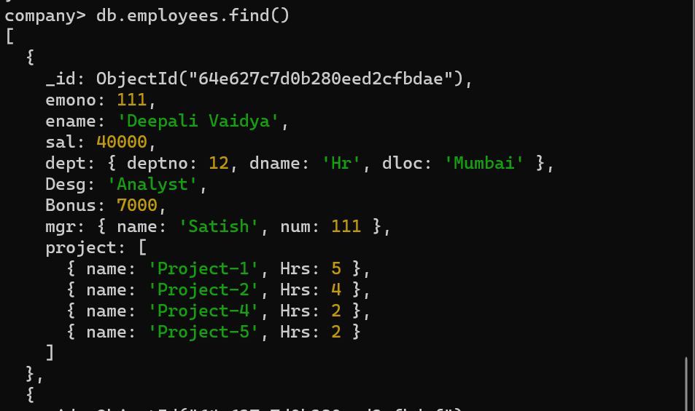

Question 4. ---------------------------------------------------------------------------------------------------------------------- $inc :
Inc stands for Incrementation i.e. it is used to increase or decrease the already existing
Values of a field by the amount mentioned .
Sal>50,000 : Bonus 2000
Sal<50,000 and sal >30,000: Bonus 1500
Sal<30,000 : Bonus 1000
Db.employees.updateMany(
{ “sal”:{$gt : 50000}},
{ $inc : { "Bonus": 2000 }}
)
Earlier Data:  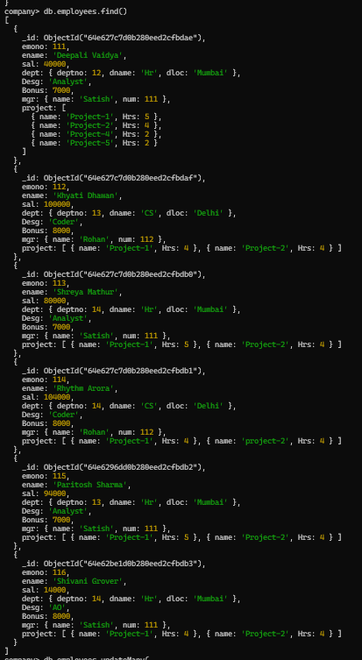 | After Command:  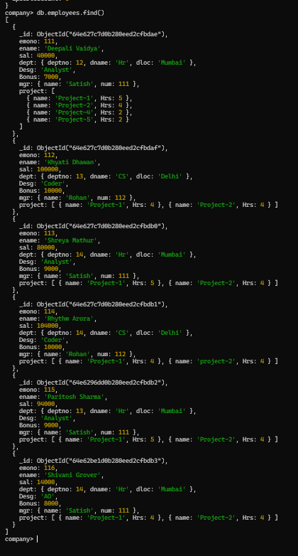

Db.employees.updateMany(
{ “sal”:{$lt: 50000, $gt :30000}},
{ $inc : { "Bonus": 1500 }}
)
Earlier Data:   | After Command:  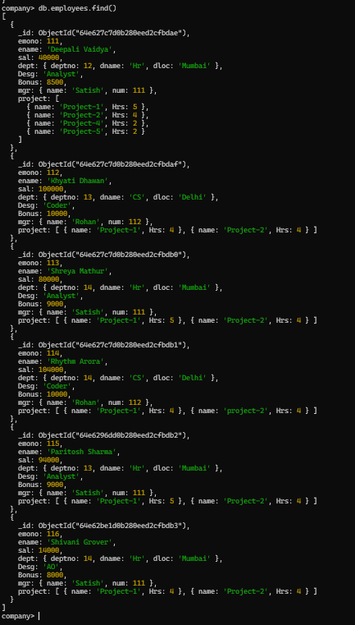

Db.employees.updateMany(
{ “sal”:{$lte :30000}},
{ $inc : { "Bonus": 1000 }}
)
Earlier Data:   | After Command: (no change)  

Question 5. ----------------------------------------------------------------------------------------------------------------------
Db.employees.updateMany(
{ “mgr.name”: “Satish”},
{$set:{“mgr.name”:”Tushar”,”mgr.num”: 3333}})
Earlier Data:   | After Command:  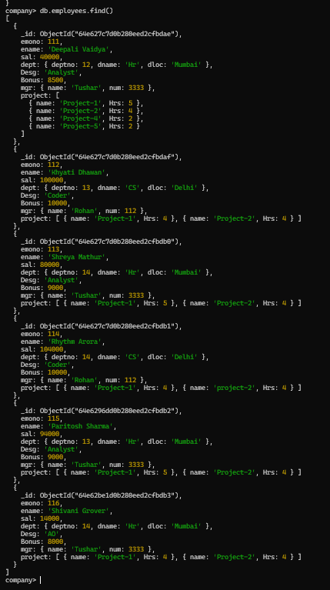

Question 6. ----------------------------------------------------------------------------------------------------------------------
First Inserted another document to the collection
db.employees.insertOne(
{ emono:117,
ename:"Joseph",
sal:10000,
dept:{ deptno:14,dname:"purchase-department",
dloc:"Mumbai"},
Desg:"Analyst",
Bonus:1000.00,
mgr:{name:"Tina",num:134},
project:[
{name:"Project-1",Hrs:4},
{name:"Project-2",Hrs:4}
]
}
)
Then ,
db.employees.updateMany(
{ "dept.dname": "purchase-department" },
{ $inc: { "sal": 15000 } }
);
Earlier Data:  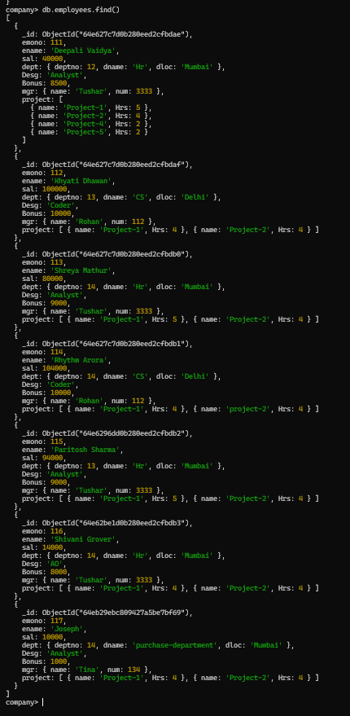 | After Command:  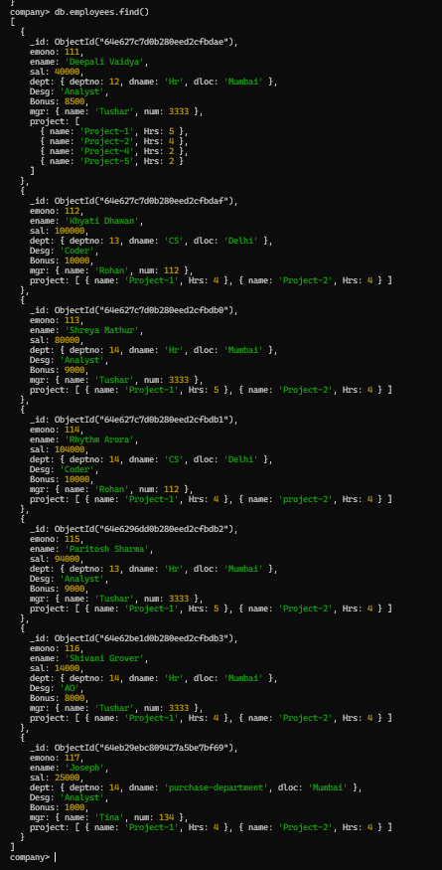

Question 7. ----------------------------------------------------------------------------------------------------------------------
db.employees.updateMany(
{ "project.name": "Project-2" },
{ $inc: { "project.$.Hrs": -2 } }
);
Earlier Data:  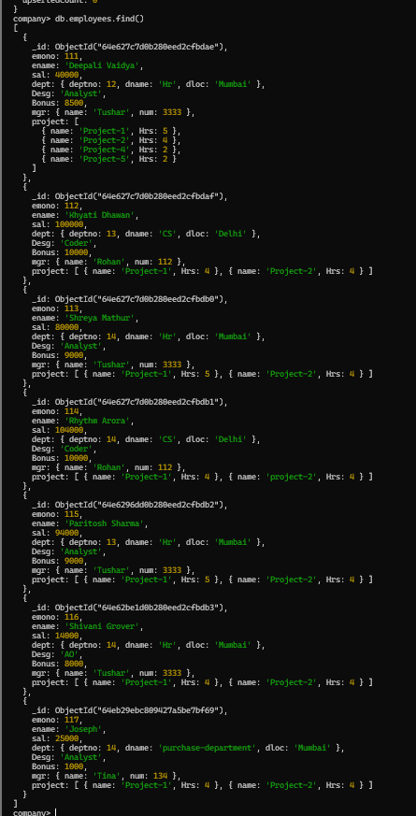 | After Command:  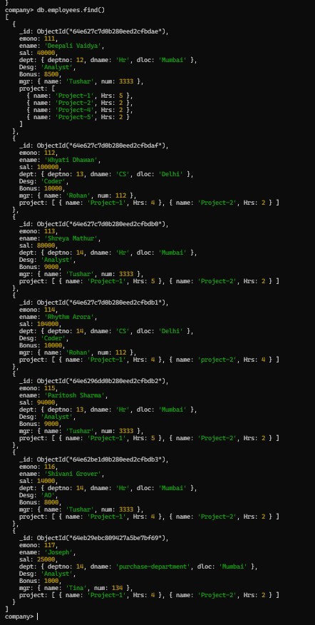



Question 8. ----------------------------------------------------------------------------------------------------------------------
db.employees.updateMany(
{"project.name":"project-2","project.Hrs":4},{$pull:{"project":{"name":"project-2"}}})
Earlier Data:  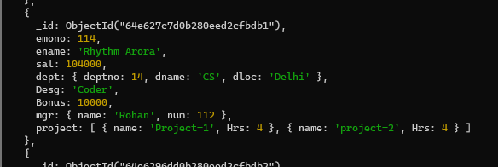 | After Command:  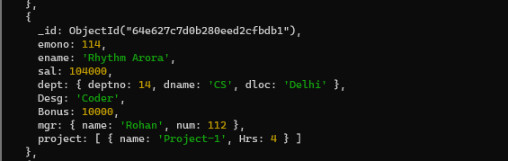



Question 9. ----------------------------------------------------------------------------------------------------------------------
db.employees.updateMany(
{ "sal": { $lt: 10000 } },
{ $set: { "sal": 10000 } }
)

Earlier Data:  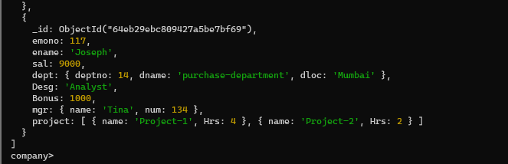 | After Command:  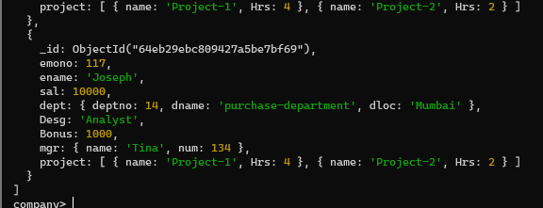



Question 10. --------------------------------------------------------------------------------------------------------------------
Db.employees.find( { $or:[ {“Bonus”: {$lt: 2000}},{“sal”:{$lt:20000}}, {“dept.dname”:”Sales”}]},{$inc:{“Bonus”:500}})

Earlier Data:  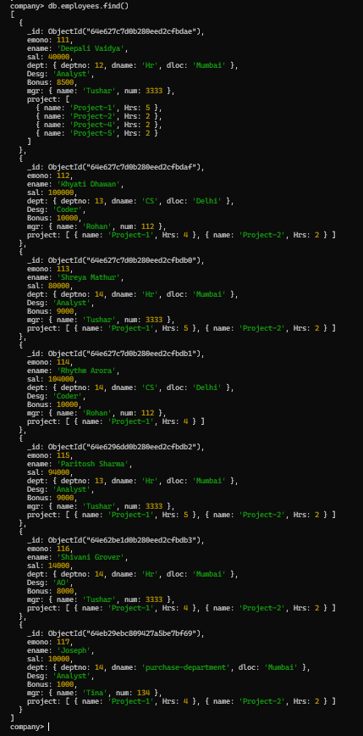 | After Command:  